

# CARE POINT

Identification of defects on moulded sheets – Large Mouldings

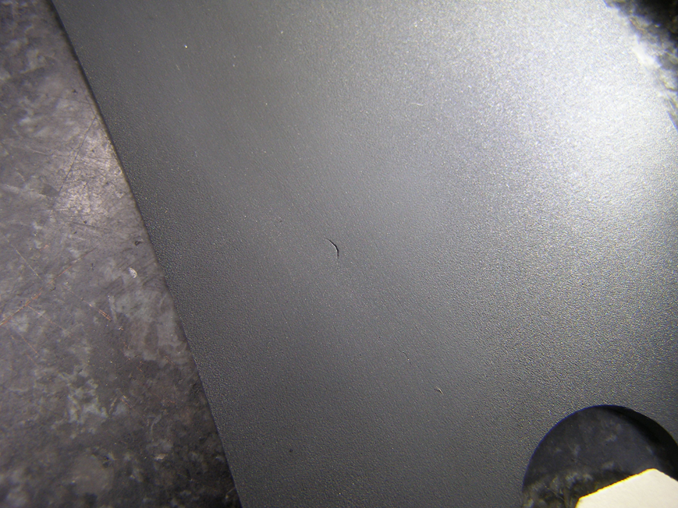

Please ensure that any surface defects found on either side of a moulded sheet are clearly identified and highlighted with a white circle prior to delivery to the cut gasket department.